# DAD 220 Module Four Major Activity Template

## Overview

Complete these steps as you work through the directions for this activity. Replace the bracketed text with your screenshots and brief explanations of the work the screenshots capture. Size each screenshot and its explanation to fit approximately one-quarter of the page with the description written below the screenshot. Review the Template Screenshot Example linked in the guidelines and rubric for this assignment to see how screenshots for your assignment should look.

Before you begin, follow steps one through four from the Module Three Major Activity Guidelines and Rubric onlyto generate tables for this assignment. Then follow the steps below to complete the activity.

## Organize and Analyze Data in Tables

1. Import the data from each file into tables.
   1. Use the Quantigration RMA database, the three tables you created, and the three CSV files preloaded into Codio.
   2. Use the import utility of your database program to load the data from each file into the table of the same name. You'll perform this step three times, once for each table.
      1. Reference notes for this step: Import the CSV File into the MySQL table. Use the following line terminators when importing: \r\n. Do not use IGNORE 1 LINES for data that does not have column headers in the first row.
   3. Provide the SQL commands you ran against MySQL to complete this step successfully.

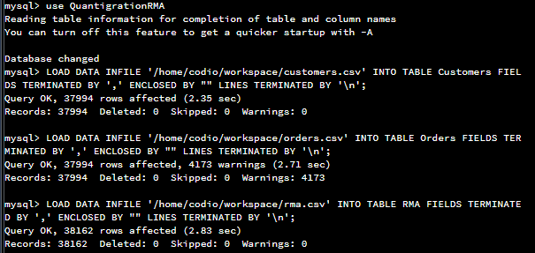

All csv files were downloaded and inspected for header rows, none found so first line was not skipped on any of the 3 files.

1. Write basic queries against imported tables to organize and analyze targeted data. For each query you run in this step, include a screenshot of the query and its output. Also, include a one- to three-sentence explanation.
   1. Write a SQL query that returns the count of orders for customers located only in Framingham, Massachusetts.
      1. This query will use a table join between the Customers and Orders tables. The query will also use a WHERE clause.
      2. Record an answer to the following question: How many records were returned?

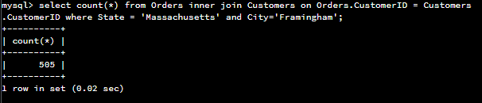

505 unique orders were received from Framingham MA;

* 1. Write a SQL query to select all of the customers located in Massachusetts.
     1. Use a WHERE clause to limit the number of records in the Customers table to only those who are located in Massachusetts.
     2. Record an answer to the following question: How many records were returned?

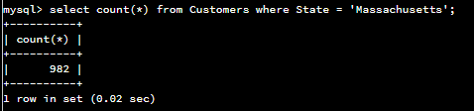

982 customers are registered In the state of Massachusetts.

* 1. Write a SQL query to insert four new records into the Orders and Customers tables using the data below.

**Customers Table**

| **CustomerID** | **FirstName** | **Lastname** | **StreetAddress** | **City** | **State** | **ZipCode** | **Telephone** |
| --- | --- | --- | --- | --- | --- | --- | --- |
| 100004 | Luke | Skywalker | 17 Maiden Lane | New York | NY | 10222 | 212-555-1234 |
| 100005 | Winston | Smith | 128 Sycamore Street | Greensboro | NC | 27401 | 919-555-6623 |
| 100006 | MaryAnne | Jenkins | 2 Coconut Way | Jupiter | FL | 33458 | 321-555-8907 |
| 100007 | Janet | Williams | 58 Redondo Beach Blvd | Torrence | CA | 90501 | 310-555-5678 |

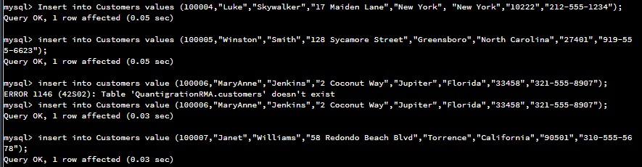

Insertions were successful, states were converted from 2 char to fully expanded for consistency with existing data

**Orders Table**

| **OrderID** | **CustomerID** | **SKU** | **Description** |
| --- | --- | --- | --- |
| 1204305 | 100004 | ADV-24-10C | Advanced Switch 10GigE Copper 24 port |
| 1204306 | 100005 | ADV-48-10F | Advanced Switch 10 GigE Copper/Fiber 44 port copper 4 port fiber |
| 1204307 | 100006 | ENT-24-10F | Enterprise Switch 10GigE SFP+ 24 Port |
| 1204308 | 100007 | ENT-48-10F | Enterprise Switch 10GigE SFP+ 48 port |

Screenshot lost due to codio timeout.

Orders 1204305/7/8 all loaded successfully, however the order 1204306 failed to load with the following error which makes sense as the description violates the length parameter of varchar(50).

*mysql> insert into Orders Values (1204306, 100005, 'ADV-48-10F', 'Advanced Switch 10 GigE Copper/Fiber 44 port copper 4 port fiber');  
ERROR 1406 (22001): Data too long for column 'Description' at row 1*

* 1. In the Customers table, perform a query to count all records where the city is Woonsocket and the state is Rhode Island.
     1. How many records are in the Customers table where the field "city" equals "Woonsocket"?

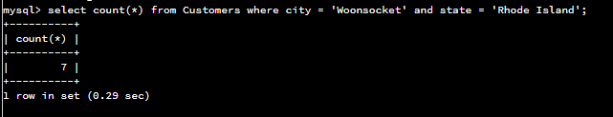

There are 7 records in the customer table where city is Woonsocket.

* 1. In the RMA database, update a customer's records.
     1. Write a SQL statement to select the current fields of **status** and **step** for the record in the **RMA** table with an **OrderID** value of "5175".
        1. What are the current status and step?

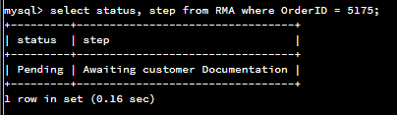

* + 1. Write a SQL statement to update the**status** and **step**for the **OrderID**, 5175 to **status**= "Complete" and **step**= "Credit Customer Account".
       1. What are the updated **status**and **step**values for this record? Provide a screenshot of your work.

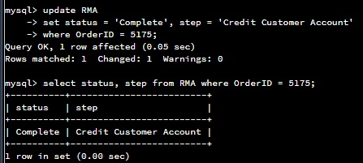

* 1. Delete RMA records.
     1. Write a SQL statement to delete all records with a reason of "Rejected".
        1. How many records were deleted? Provide a screenshot of your work.

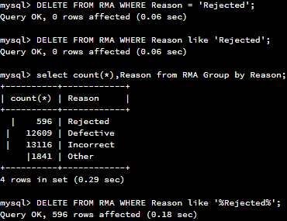

It is unclear why the first 2 delete statements failed and the last one passed. Output matches the select count however, so it seems to have caught them all.

1. Create an output file of the required query results.

Write a SQL statement to list the contents of the Orders table and send the output to a file that has a .csv extension.

